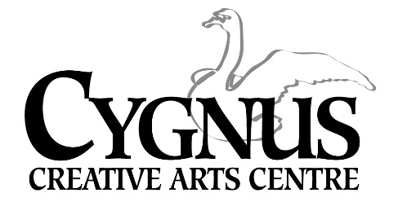
5045 English Creek Avenue, Egg Harbor Township, NJ 08234
609.272.1199/ fax: 609.272.1935
www.cygnusarts.org / www.info@cygnusarts.org

The Cygnus Strings!


Ms. Kate Wyatt is excited to bring back her String Class! This program is great for students who have a passion for studying and performing Strings! This class will focus on learning a variety of music to be performed throughout the area during the Fall and Holiday season.

Ms. Wyatt is inviting students who
study the Violin, Viola, Cello and Bass to Join!

Students 8yrs and up with playing experience will be placed according to ability.

All Classes will be on Mondays beginning October 6 - November 24, 2025
Time: 6pm-7:30pm
Tuition cost is $195 per student.

Ensemble size is limited to 15. Early sign ups are encouraged. Performance dates and time throughout the holiday season will be given in class.

Please contact Cygnus at 609.272.1199 / email: info@cygnusarts.org to schedule an evaluation and/or questions for Ms. Wyatt

