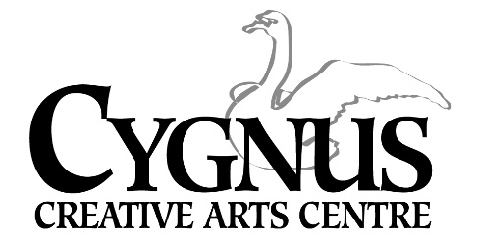

5045 English Creek Avenue, Egg Harbor Township, NJ 08234

609.272.1199/ fax: 609.272.1935

www.cygnusarts.org / www.info@cygnusarts.org

The Cygnus Strings!



Ms. Kate Wyatt is excited to bring back her String Class! This program is great for students who have a ***passion*** for studying and performing Strings! This class will focus on learning a variety of music to be performed throughout the area during the Fall and Holiday season.

Ms. Wyatt is inviting students who

study the Violin, Viola, Cello and Bass to Join!

***Students*** 8yrs and up with playing experience will be placed according to ability.

*All Classes* will be on Thursdays beginning September 25- November 13, 2025

Time: 6pm-7:30pm

Tuition cost is $195 per student.

Ensemble size is limited to 15. Early sign ups are encouraged. Performance dates and time throughout the holiday season will be given in class.

Please contact Cygnus at 609.272.1199 / email: info@cygnusarts.org to schedule an evaluation and/or questions for Ms. Wyatt