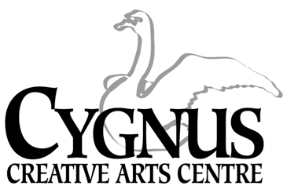
5045 English Creek Avenue, Egg Harbor Township, NJ 08234
609.272.1199 / fax:609.272.1935
www.cygnusarts.org / email: info@cygnusarts.org

S.T.A.R. DANCE DIVISION
Students Taught the Arts as Recreation

2024 Summer / Fall Session
Start Date: July 9, 2024

Time | TUESDAY
4:30-5:20pm | Tap/Jazz/ Hip Hop 9-12yrs
5:25-6:10pm | Moving Dancers 3-5yrs
6:15-7:05pm | Tap /Jazz /Hip Hop 6-8yrs
7:10-8:00pm | Ballet / Contemporary / 6-yrs-up

*$185 / + Recital Costume

Tuesday Dates 2024
July 9, 16, 23, 30 / August 6, 13, 20, 27 / September 3, 10, 17, 24
October 1, 8, 15, 22, 29 / November 5, 12, 14, 15
*Dress Rehearsal: Thursday November 14, 4:00pm / **Recital: Friday November 15, 7pm

*The Dress Rehearsal and Recital will be held in the Egg Harbor Township Community Center.

This Dance Division offers a level-up with affordable pricing, quality instruction and a variety of classes to meet needs of all residents throughout Atlantic County.
This program is open to everyone and welcomes anyone looking to have Recreational Fun.

*Program fee includes a Recital costume subsided by Cygnus.
*Costumes will be ordered for students performing in the Recital.
*Costumes will not be given to the student if the student drops the class.

*All fees are paid in FULL and are Non-Refundable. Fees are not pro-rated for late enrollment.
*All classes not filled by the end of enrollment period are subject to change and/or combined or cancelled depending on the number of participants.
Register online at www.cygnusarts.org or in person Monday-Thursday 4:00pm-7:00pm

