**CHILDREN’S DANCE CLASSES**

SEPTEMBER 12, 2023-JUNE 10, 2024 (36 Weeks)

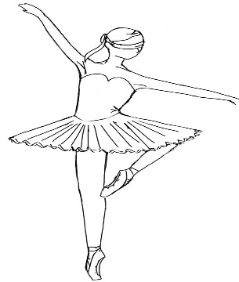

[This Photo](https://missyrayney.deviantart.com/art/Ballerina-Base-197937139) by Unknown Author is licensed under [CC BY-SA](https://creativecommons.org/licenses/by-sa/3.0/)

**Petite Ballerina** / 4-5yrs Tuesdays 4:45-5:30pm-45 minutes

**$101-9 week Sessions.**

**Fundamental Level /** 5-6yrs Tuesdays 5:35-6:35pm-1 hour

**$135-9 week Sessions.**

**Pre-Ballet / 6-7yrs** Mondays and Wednesday 4:30-5:30pm

**$270-9 week sessions**

Registration is rolling. Tuition is pro-rated for middle of quarter registration.

Tuition is payable every 9 wks. / 4 Quarters for a total of 36 weeks

Recital in June.

Office is open Monday-Thursday 4:30pm-7:00pm or register online.

***Schedule is subject to change based on enrollment.***

***Any class that doesn’t fill will be cancelled or combined.***

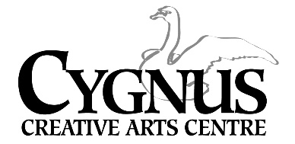

5045 English Creek Avenue Egg Harbor Township, NJ 08234

609.272.1199 / [www.info@cygnusarts.org](http://www.info@cygnusarts.org) / [www.cygnusarts.org](http://www.cygnusarts.org)