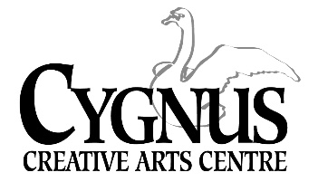

**Theater and Acting Classes Fall 2023**

**Theatre & The Actor**

**Ages:** Middle School - High School

**Dates:** Wednesdays September 27- November 29, 2023 **Time:** 7:00pm-8:00pm

During this session we will navigate an Actors mind through movement, short plays, and workshopping different acting techniques. The actor will be focusing on the development of dramatic and comedic monologues. Actors will be introduced to acting techniques that involve Method Acting, Meisner, and so on. They will explore vocal and physical choices to develop an authentic performance. Actors have the chance to engage their core using movement. Being able to tell a story through body as well as voice and face. Movement can be an opportunity for actors to explore thought, feeling, and action. The capabilities that an actor holds to analyze elements on stage to bring the character alive!

**Acting for the Camera**

**Ages:** Middle School - High School

**Dates:** Wednesdays September 27- November 29, 2023 **Time:** 5:45-6:45pm

Over the duration of this session we will approach the fundamentals of screen acting technique. This

includes partner scene work, screenwriting, and audition practice while utilizing acting on camera.

Learning the film process and terminology. Engaging with physicality and voice for screen. The actor will gain knowledge to apply scripts on to the screen. We will focus on screen acting improv using commercial exercises and complex dramatic and comedic scenes. The actor has a chance to study the craft of successful screen acting and confidence in front of the camera.

**PARIS MONÉT**

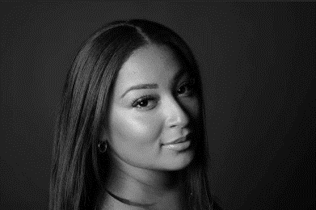

Paris is an NYU Tisch Drama graduate. She advocates to dismantle patriarchal structures, women’s rights, and child mental health awareness! She’s a screen and stage actress, voiceover actor, dance choreographer, blogger, and by the time she’s old and gray she wants to have a nonprofit company for all aspiring dancers and actors! She believes that you can do it all, no matter what box you're checked in. She wants to make an impact on the world and become an official humanitarian in the near future. Paris believes that the world is overdue for change. She lives by this quote “influence the room, don’t adapt”!

5045 English Creek Avenue, Egg Harbor Township, NJ 08234 609.272.1199/ [www.cygnusarts.org](http://www.cygnusarts.org) / [info@cygnusarts.org](mailto:info@cygnusarts.org)