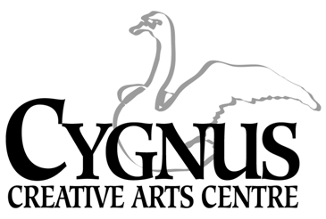
5045 English Creek Avenue, Egg Harbor Township, NJ 08234
609.272.1199 / fax:609.272.1935
www.cygnusarts.org / email: info@cygnusarts.org

S.T.A.R. DANCE DIVISION
Students Taught the Arts as Recreation
2023 Summer / Fall Session
Start Date: July 9-November 17, 2023
 | TUESDAY |  | WEDNESDAY
4:30-5:15pm | 101 Intro to Dance 3-5yrs | 4:30-5:15pm | 102 Dance II 4-5yrs.
5:20-6:05pm | 202 Tap/Jazz/Hip Hop 6-8yrs | 5:20-6:05pm | 201 Ballet/Jazz 6-8 yrs.
6:10-6:55pm | 302 Tap/Jazz/Hip Hop 9-12yrs | 6:10-7:00pm | 401 Ballet/Contemp 8-11yrs.
7:00-7:45pm | 402 Ballet/Contemp 12yrs-up. | 7:00-7:45pm | 301 BalletJazz II 9-12 yrs

*$175 / 20 Sessions + Recital Costume

Tuesday Dates 2023
July 11, 18, 25 / August 1, 8, 15, 22, 29 / September 5, 12, 19, 26
October 3, 10, 17, 24 / November 7, 14

*Dress Rehearsal: Thursday November 16, 4:00pm / **Recital: Friday November 17, 7pm

Wednesday Dates 2023
July 12, 19, 26 / August 2, 9, 16, 23, 20 / September 13, 20, 27
October 4, 11, 18, 29 / November 1, 8, 14

*Dress Rehearsal: Thursday November 16, 4:00pm / **Recital: Friday November 7pm

*The Dress Rehearsal and Recital will be held in the Egg Harbor Township Community Center.

This Dance Division offers a level-up in dance training with affordable pricing, quality instruction and a variety of classes to meet needs of all residents throughout Atlantic County.
This program is open to everyone and welcomes anyone looking to have Recreational Fun.
*Program fee includes a Recital costume subsided by Cygnus.
*Costumes will be ordered for students performing in the Recital.
*Costumes will not be given to the student if the student drops the class.

*All fees are paid in FULL and are Non-Refundable. Fees are pro-rated for late enrollment.
*All classes not filled by the end of enrollment period are subject to change and/or combined or cancelled depending on the number of participants.
Register online at www.cygnusarts.org or in person Monday-Thursday 4:00pm-7:00pm

