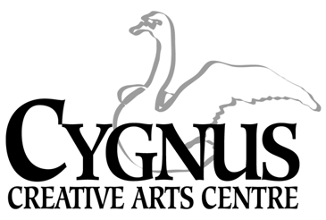
5045 English Creek Avenue, Egg Harbor Township, NJ 08234
609.272.1199 / fax:609.272.1935
www.cygnusarts.org / email: info@cygnusarts.org

S.T.A.R. DANCE DIVISION CLASS OFFERINGS
“Students Taught Art as Recreation”
2023 Winter/Spring Session
Start Date: January 17, 2023
 | TUESDAY |  | WEDNESDAY
10:30-11:15am | Mommy n Me 18m-2yrs/ 6wks $70
11:20-12:05am | Rising Stars 2-3yrs / 6wks $70
4:30-5:15pm | Intro to Dance 3-5yrs | 4:30-5:15pm | Dance II 4-5yrs.
5:20-6:05pm | Tap/Jazz/Hip Hop 6-8yrs | 5:20-6:05pm | Ballet/Jazz 6-8 yrs.
6:10-6:55pm | Tap/Jazz/Hip Hop 9-12yrs | 6:10-6:55pm | Ballet/Contemporary 8-11yrs.
7:00-7:45pm | Ballet/Contemporary 12yrs-up. | 7:00-7:45pm | Ballet / Jazz II 9-12 yrs

*$175 / 20 Classes + Recital Costume

Tuesday Dates 2023
January 17, 24, 31 / February 7, 14, 21, 28 / March 7, 14, 21, 28
April 4, 18, 25 / May 2, 9, 16, 23, 30
*Dress Rehearsal: Thursday June 8, 4:00pm / *Recital: Friday June 9, 7pm

Wednesday Dates 2023
January 18, 25 / February 1, 8, 15, 22 / March 1, 8, 15, 22, 29
April 5, 19, 26 / May 3, 10, 17, 24, 31
*Dress Rehearsal: Thursday June 8, 4:00pm / *Recital: Friday June 9, 7pm

*The Dress Rehearsal and Recital will be held in the Egg Harbor Township Community Center.

This Dance Division offers affordable pricing, quality instruction and a variety of classes to meet needs of all residents throughout Atlantic County.
This program is open to everyone and welcomes anyone looking to have Recreational Fun.

*Program fee includes a Recital costume subsided by Cygnus.
*Costumes will be ordered for students performing in the Recital.
*Costumes will not be given to the student if the student drops the class.

*All fees are paid in FULL and are Non-Refundable. Fees are not pro-rated for late enrollment.
*All classes not filled by the end of enrollment period are subject to change and/or combined or cancelled depending on the number of participants.
Register online at www.cygnusarts.org or in person Monday-Thursday 4:00pm-7:30pm.

