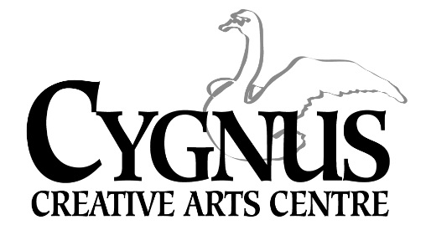
5045 English Creek Avenue Egg Harbor Township, NJ 08234
609.272.1199 / fax: 609.272.1935
www.cygnusarts.org / info@cygnusarts.org

Art for the Young at Heart
Classes are Free for the residents in Atlantic County. All Class sizes are limited.
Everyone will register in advance to insure a place in class.
All classes are subject to change and /or rotate due to instructor availability.

Art for the Young at Heart: Tai Chi Tuesdays 9:30am.-10:30am. Beginner-Intermediate
Friday 9:30am-10:30am. Intermediate-Advanced.

- Tai chi is a Chinese-style of energy art embracing the mind, body and spirit. Originating in ancient China, Tai chi is one of the most effective exercises for health of mind and body. Although an art with great depth of knowledge and skill, it is easy to learn and soon delivers its health benefits. The ultimate purpose of tai chi is cultivate the qi or life energy within us to flow smoothly and powerfully throughout the body. Total harmony of the inner and outer self comes from the integration of mind and body, empowered through healthy qi through the practice of Tai chi.

Art for the Young at Heart: Yoga Mondays 9:30am.-10:30am. All levels
- Yoga is an ancient and complex practice, rooted in Indian philosophy. It began as a spiritual practice but has become popular as a way of promoting physical and mental well-being. Yoga as practiced in the United States typically emphasizes physical postures (asanas), breathing techniques (pranayama), and meditation (dyana). Although classical yoga also includes other elements. Studies have suggested possible benefits of yoga for several aspects of wellness, including stress management, mental/emotional health, promoting healthy eating/activity habits, sleep, and balance.

Art for the Young at Heart: Drawing and Painting Classes Thursdays 9:30am-11:00am. All levels
Creativity and Imagination Mondays 2:00pm-3:30pm All levels

- Visual art classes begin with basic skill building exercises in drawing and painting for those who never have taken a formal art class. Individual attention is given to all students in such that the class is taught in an academy format. Students will be encouraged to work from both life and photographic references to achieve a naturalistic painting or drawing. Subject matter is determined by the students’ interest while the instructor aids in technique, paper selection, blending colors, selecting brushes/pencils and achieving a balanced composition. Students are encouraged to experiment with a variety of techniques and styles allowing them to find their own expression.

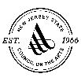
Made possible by funds from the Atlantic County Office of Cultural & Heritage Affairs, a partner of the New Jersey State Council on the Arts.

