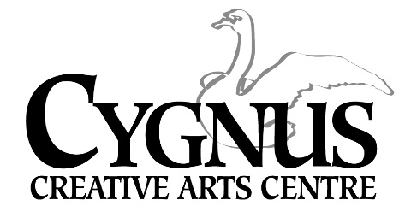
5045 English Creek Avenue, Egg Harbor Township, NJ 08234
609.272.1199/ fax: 609.272.1935
www.cygnusarts.org / www.info@cygnusarts.org

The Cygnus Strings!

Ms. Kate Wyatt is excited to introduce a New performing arts program for students who have a passion for studying and performing Strings! This new program will be focused on learning a variety of holiday songs to be performed throughout the area during the holiday season.
Ms. Wyatt is inviting students who
study the Violin, Viola, Cello and Bass to Join!
Previous students 8yrs and up with playing experience will be placed according to ability.
New students 10yrs-up with playing experience need to schedule a placement evaluation on September 29 beginning at 5pm.

All Classes will be on Thursdays October 6, 13, 20, and 27 / November 3, 17 Time: 6pm-8:30pm
Tuition cost is $225 per student.

Ensemble size is limited to 15. Early sign ups are encouraged. Performance dates and time throughout the holiday season will be given at 1st class.
Please contact Cygnus at 609.272.1199 / email: info@cygnusarts.org to schedule an evaluation and/or questions.

