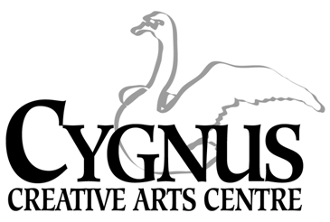
5045 English Creek Avenue, Egg Harbor Township, NJ 08234
609.272.1199 / fax:609.272.1935
www.cygnusarts.org / email: info@cygnusarts.org

S.T.A.R. DANCE DIVISION
Students Taught the Arts as Recreation
2024 Winter / Spring Session
Start Date: January 9, 2024
 | TUESDAY |  | THURSDAY
4:30-5:15pm | 101 Intro to Dance 3-5yrs | 4:30-5:15pm | 102 Dance II 4-5yrs.
5:20-6:05pm | 202 Tap/Jazz/Hip Hop 6-8yrs | 5:20-6:05pm | 201 Ballet/Jazz 6-8 yrs.
6:10-6:55pm | 302 Tap/Jazz/Hip Hop 9-12yrs | 6:10-7:00pm | 401 Ballet/Contemp 8-11yrs.
7:00-7:45pm | 402 Ballet/Contemp 12yrs-up. | 7:00-7:45pm | 301 BalletJazz II 9-12 yrs

*$185 / 20 Classes + Recital Costume

Tuesday Dates 2024
January 9, 16, 23, 30 / February 6, 13, 20, 27 / March 5, 12, 19, 26
April 9, 16, 23, 30 / May 7, 14, 21, 28 / June 6, 7
*Dress Rehearsal: Thursday June 6, 4:00pm / **Recital: Thursday June 7, 7pm

Thursday Dates 2024
January 11, 18, 25 / February 1, 8, 15, 22, 29 / March 7, 14, 21, 28
April 11, 18, 25 / May 9, 16, 23, 30 / June 6, 7
*Dress Rehearsal: Thursday June 6, 4:00pm / **Recital: Friday June 7, 7pm

*The Dress Rehearsal will be held in the Egg Harbor Township Community Center.
** The Recital is possibly held at the Fernwood Middle School in Egg Harbor Township
This Dance Division offers a level-up with affordable pricing, quality instruction and a variety of classes to meet needs of all residents throughout Atlantic County.
This program is open to everyone and welcomes anyone looking to have Recreational Fun.

*Program fee includes a Recital costume subsided by Cygnus.
*Costumes will be ordered for students performing in the Recital.
*Costumes will not be given to the student if the student drops the class.

*All fees are paid in FULL and are Non-Refundable. Fees are not pro-rated for late enrollment.
*All classes not filled by the end of enrollment period are subject to change and/or combined or cancelled depending on the number of participants.
Register online at www.cygnusarts.org or in person Monday-Thursday 4:00pm-7:00pm

